Raees Zeeshan ali Day-2 Assignment

TASK: 01

Create directories which would have the following structure by using only mkdir command:

consultadd/

|-- Python

|   `-- Django

|       `-- restframework

|-- java

|   `-- springboot

|-- javascript

|   `-- angular

|   `-- react

|-- SQL

|   `-- mysql

`-- bootcam

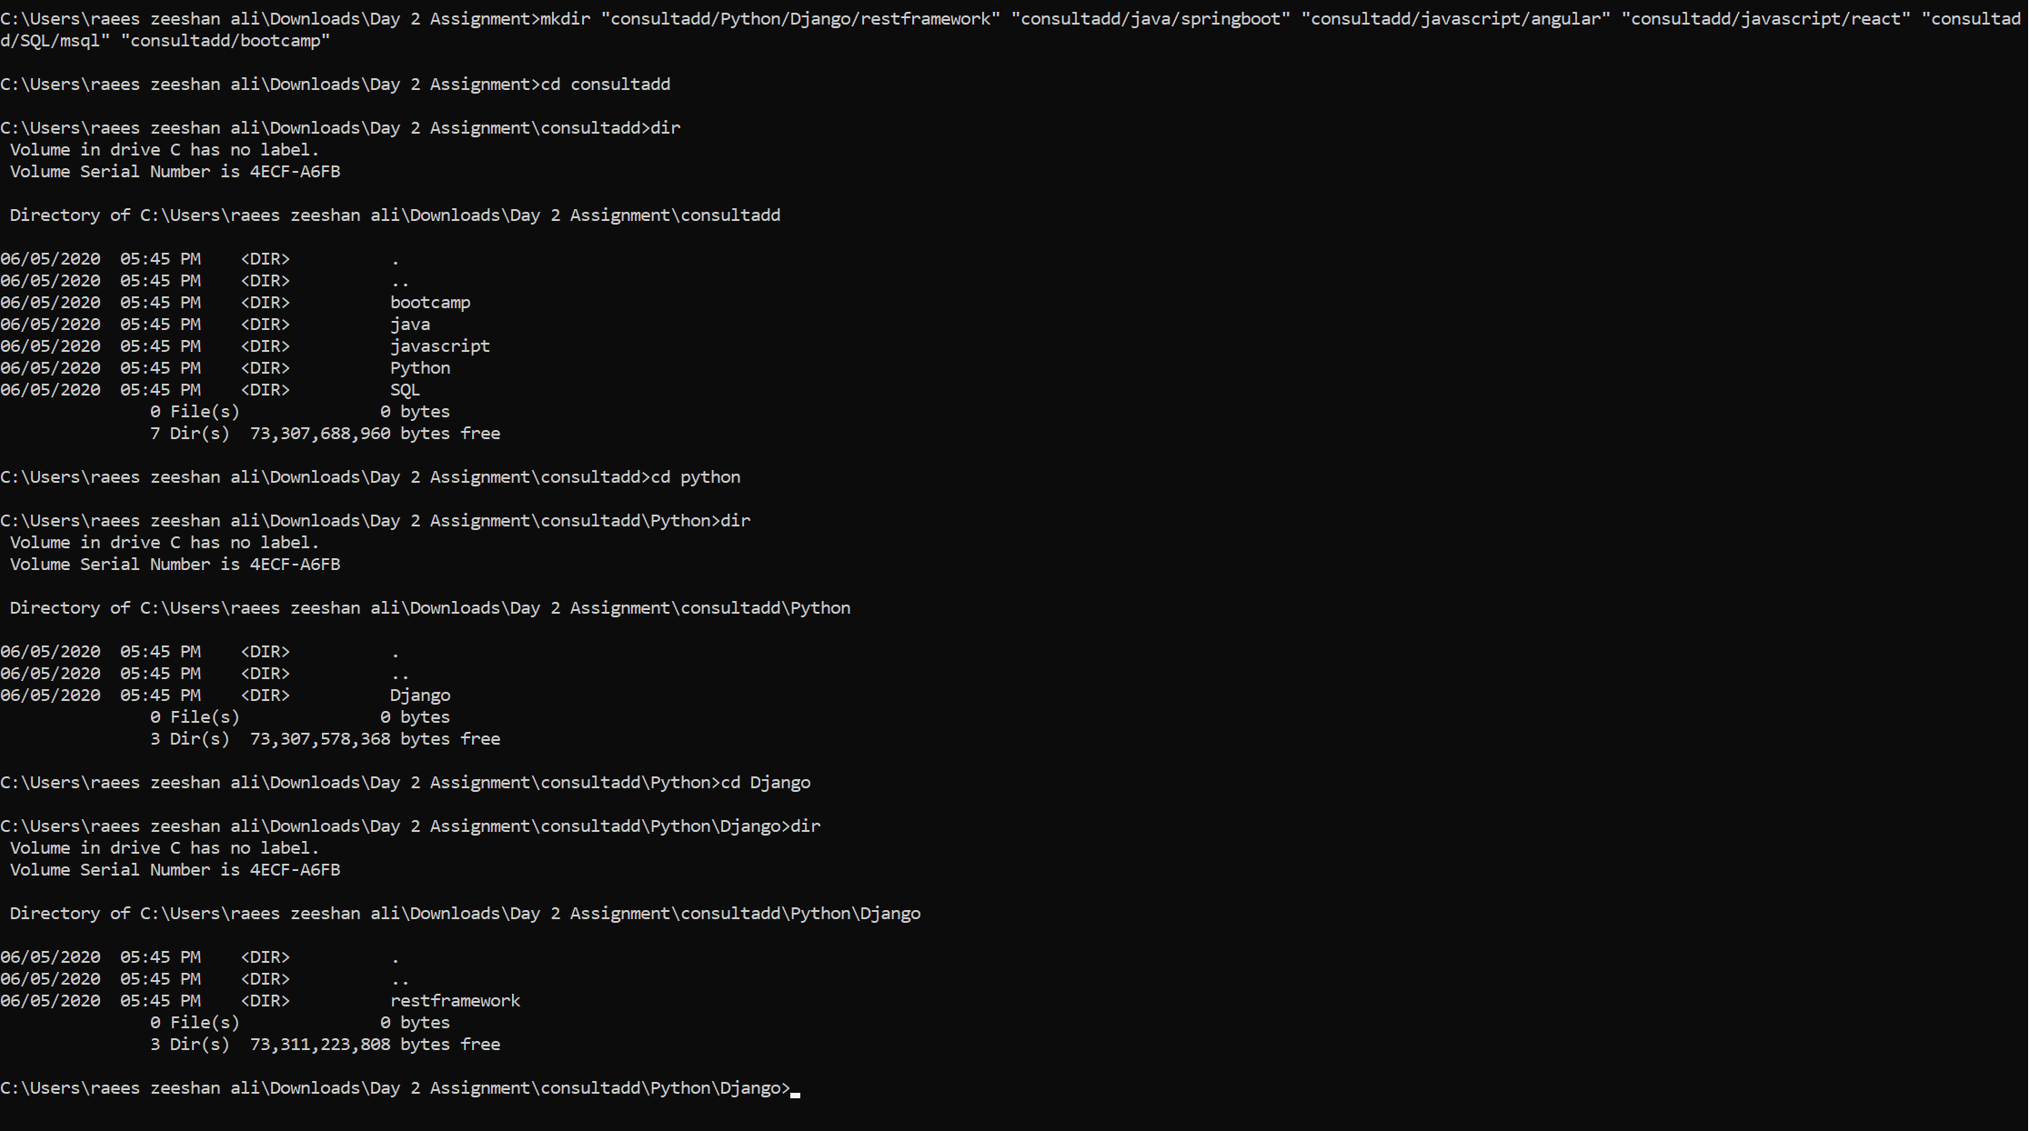

**TASK 02:**

Create Directory called consultadd

Inside that create 5 more directories named them as dir1, dir2, dir3, dir4 and dir5



What would be the output of Long Listing after creating these directories?

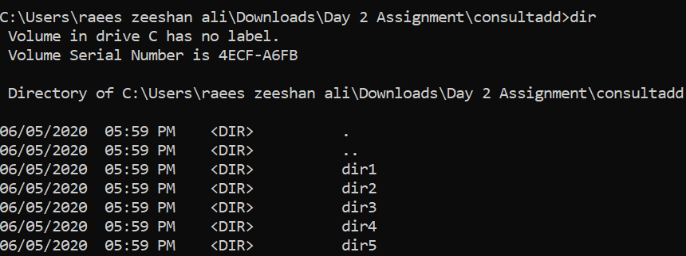

List all the directories with ls and echo * and see the difference.

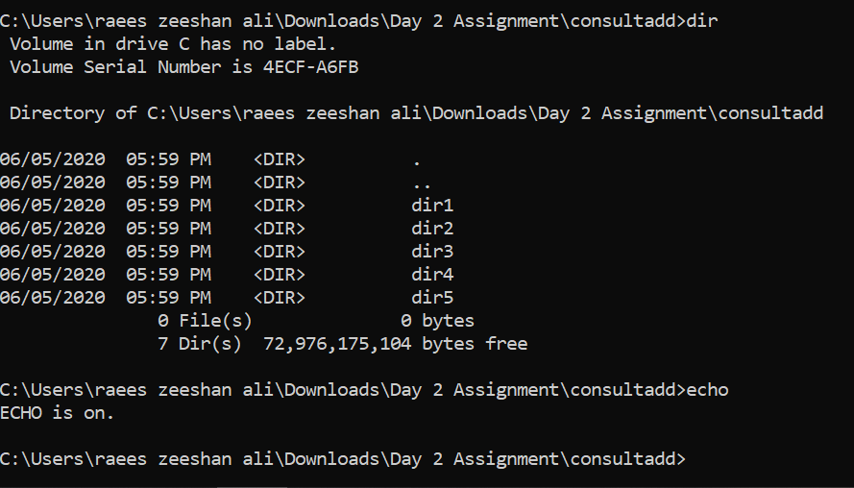

Create a 2 files named them file1.txt and file2.txt inside dir3

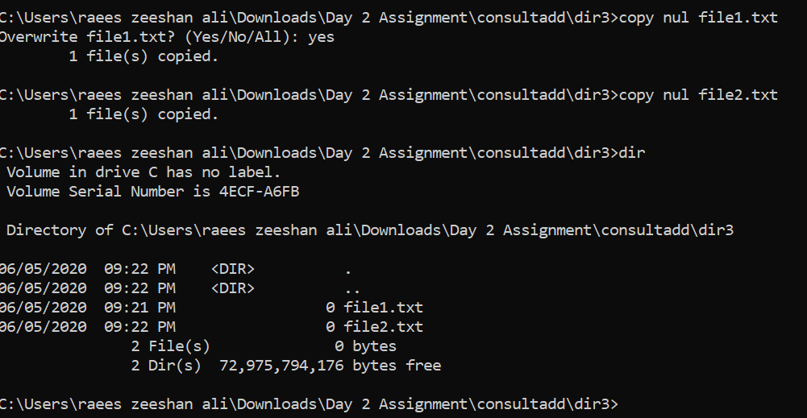

Move dir5 into the dir3

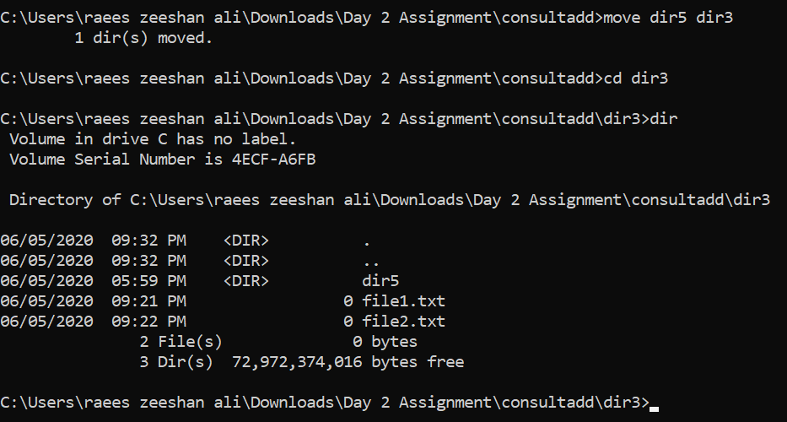

Remove dir 3 after moving all files from dir3 to dir2.

Go to the dir2 and create one more file with name index.html

Move to top level directory

Check the permission of all files and directory from current place make sure when you do **pwd** it should be on consultadd

Rename all files of dir2 with extension of .txt to .py

**HINT:** Use Rename command - Make sure you install it first.

**TASK: 03**

**What is Nano Editor?**

GNU nano is a text editor for Unix-like computing systems or operating environments using a command line interface. It includes all the basic functionality you’d expect from a regular text editor

**How to create a sample file in Nano Editor**?

Nano file name

**How to save file**?

Ctrl +o

**What is Vi Editor?**

The default Unix based operating system editor

**operation in Vi Editor**

The UNIX vi editor is a full screen editor and has two modes of operation:

Command mode commands which cause action to be taken on the file, and

Insert mode in which entered text is inserted into the file.

**TASK: 04**

Type **finger** to see your account and name.

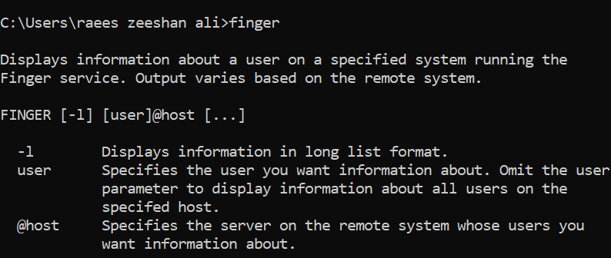

* Type **cal** to see this month’s calendar.
* Create a file and give a name random.txt to it with content into it which say “Hello Welcome to the Consultadd Inc Bootcamp”.
* Display the same content using **cat** command.

**TASK: 05**

**Explain the workflow of the Internet in one paragraph.**

In today world internet is growing very faster and it is impossible to hide yourself from the explosiveness of [www.com](http://www.com) which we constantly see on television, radio. As the internet has become a very huge part of human’s life to its good to have the understanding that, how internet works. Internet is the global network of all the computers and each computer is connected with to the other computer with a unique address which is called IP Address and it must be in the range of 0 – 255. Every computer needs to communicate on the internet with its build in computer system. The protocol stack on the internet is called TCP/IP protocol and different protocol layer work inside each other. The packet travels from one computer to another computer over the internet when one computer send a request to other computer and it is maintained by internet service provider and refer to as port server and give access to network. Router and packet switches are there and this is how a packet finds its way to the network and then different domain name and address resolutions are used. This is how the internet works.

**How LAN is different from the WAN network?**

LAN:

1. A local area network is a group of a computers and network connected together in the same area like a building, home, university.
2. The bandwidth transmission and data transfer rate are much higher in local area network.
3. The setup cost is low with low maintenance and the transmission error very less.
4. Its more secure than other networks.

WAN:

1. A wide area network is not restricted to a geographical. Internet is a great example of wide area network.
2. This technology is high speed and relatively expensive.
3. The cost of setting up is also more than l LAN and it cost lots of the maintenance

* It is open to threats